Nutrition Assistant Web App Report
Application name: Nutricheck
Live website url: https://drive.google.com/file/d/1xNQtir7lDM0P9NdaWEpyf6RaoBmJmXOR/view?usp=sharing
Github repo: https://github.com/238x1a05h5-code/Nutrition-Assistant
Team members:
Kadiyala Sanjay Paul
Doguparthy Venkata Siva Kumar
Shaik Salauddin
Shaik Mahammad Khasim
Nageswari Penti

1.Introduction

1.1 Overview
People at this time are very concerned about their health and nutrition. Most of them are dieting, but are not good at choosing the right nutrition. A healthy diet is a healthy eating habit. A good diet is a balanced diet that meets all the needs of the body, such as foods that contain nutrients such as proteins, carbohydrates, fats, vitamins, mineral salts, water and salts in the quantities required.Hence, healthy eating and nutritious food have become an essential part of everyone’s lifestyle to achieve a balanced and healthy life in such busy and hectic environment.
Hence, to make their fitness path a bit smoother and to enhance their experience, We have created an Web application to provide a broader approach in providing a better living through nutritious and fit diet plan to the users.
This application will use knowledge representation and semantic web technology in the form of the Food APIs to produce the diet plans for the users.

1.2 Purpose
The application will start by signing up or logging the user with the Nutricheck application. The signup and login screen which will be useful to the user to manage their activities in the application. The application provides three main user functionalities, namely, food uploading, reports, health blog.
- By food Uploading feature you can take the snap of the food that you eat and upload the food to get the nutrient values in that food.
- Progress Report activity is used to present the weekly and daily reports of the nutrients consumed by the user in the form of a line and pie chart.This report also helps the user to take future decisions based on past reports.
- The last activity is the health blog which can be used to see different blogs to improve health and life.

LITERATURE SURVEY

Existing problem
We have performed an electronic search to identify the relevant apps from three major commercial app stores, i.e., Google Play Store, Apple App Store, and Microsoft Store. We found three apps namely “Weight Loss Coach & Calorie 4 Counter - Nutright”, “Foodzilla! Nutrition Assistant, Food Diary, Recipe” and “Fitatu Calorie Counter - Free Weight Loss Tracker” for measuring internal consistency.
Foodzilla lets your clients take pictures of their meals and uses AI technology to extract and
auto-populate as much data as possible from each photo. Then, the image and all the relevant info are automatically sent to you within seconds!

Proposed Solution
In the Proposed solution the web application “Nutricheck” will use knowledge representation and
semantic web technology in the form of the Food APIs to produce the diet plans for the users.
With this application users can take pictures of the food and upload the food to get the nutrient values
in that food ,this is done by using the Food APIs.
The proposed application will also help the user to see his/her activity by providing the weekly
progress report in a bar chart format by simply clicking the bar chart.The reports indicate the user about the calories intake and warn them if they are taking too less or too more calories in a day.
Nutricheck also offers different health blogs in the blogs section to make the user more active and
motivated.

Theoretical Analysis

Block diagram
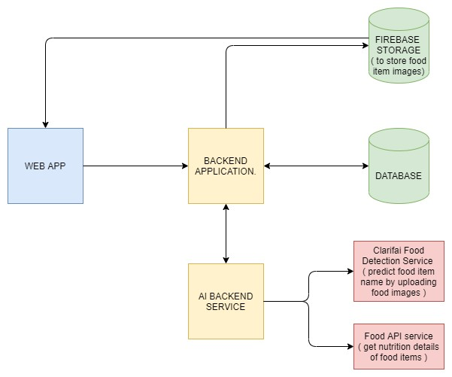
3.2 Hardware / Software Requirements Software designing requirements:
- React frontend library.
- Flask framework to build backend application.
- Docker - to dockerize application and ship to server cluster.
- Redhat openshift to deploy application.
Requirements to use the application

Hardware Requirements
- Any device with minimum RAM of 2GB. We recommend mobile for a better experience.
- Processor: Minimum 1 GHz; Recommended 2GHz or more
- Internet connection with network or wifi or LAN
Software Requirements
- Any browser recommended chrome

EXPERIMENTAL INVESTIGATIONS
- After choosing the project we have seen the working of existing solutions. We have noted down the essential requirements and thought of new requirements which will help the user to organise their food habits.
- Investigated about healthy food, how food can affect the health, How many calories can a normal person consume per day, Found the formulas to calculate the calories of a person based on age, gender and exercise. Not only calories but other important nutrients like carbs, fats, proteins, calcium as well.
- Did research to find the best API’s for food recognition and to get the nutrients and calorie details of food. Ended up using clarifai API for food recognition and nutrionix api to get the nutrients in the food.
- Investigated about the best plans for diet to provide any type of customer to avoid excess or lack of food related issues and we provided the diet plan in the blog section.

Flowchart
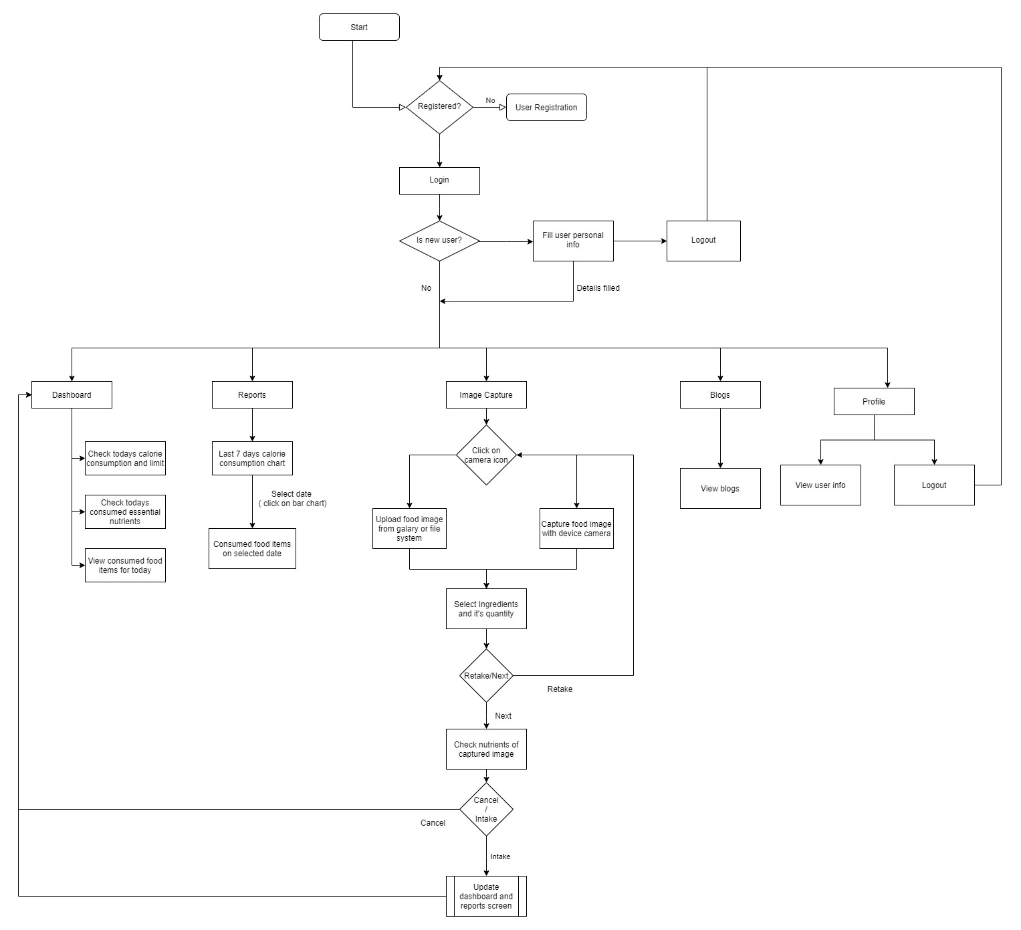

Result
- Users can upload or take pictures and get the details like calories and other nutrients of related food.
- The intake food will add to users food and users can see the updated progress bar of calories.
- Also users can see the consumed calories of past week and food taken on particular day
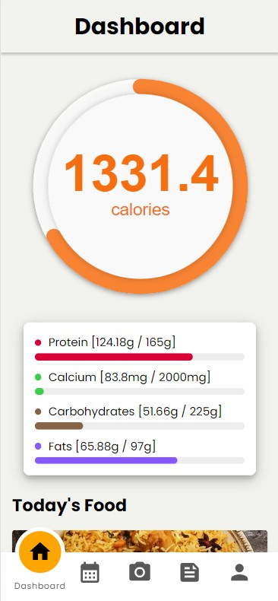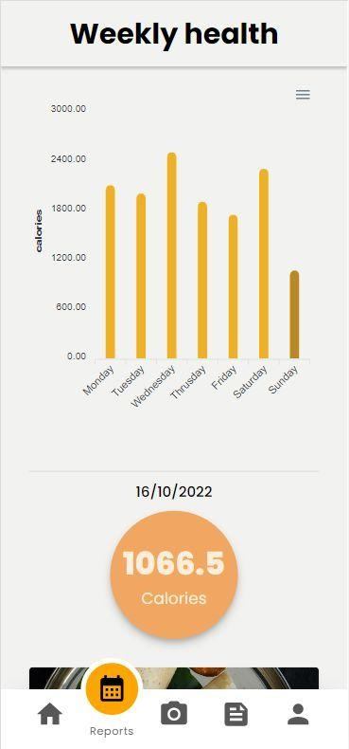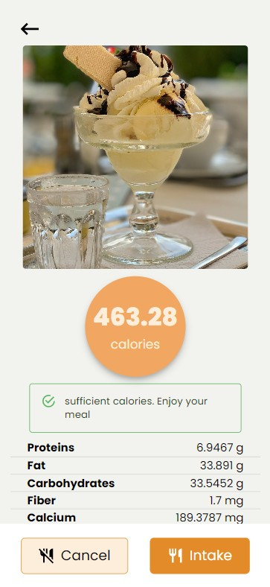

ADVANTAGES
- It provides general awareness of nutrients in food with the reports that are being generated from the food they eat.
- It helps a targeted way to focus on your health
We all know that when we have a goal, it is necessary to have tools to help us focus and refocus because life is full of distractions. A Nutricheck can help you do this.
- It can cause you to think about and consider a food choice.
- It allows you to analyse your own food choices to assess and tweak your eating plan and patterns.
- You can analyse your choices and slowly make realistic tweaks to your eating patterns to improve your health.

DISADVANTAGES
- It can actually remove a level of mindfulness because the goal is to hit target numbers NOT listen to your body.
What if you are hungrier one day? We might be compelled to restrict if we don’t have any calories left to consume per the tracker recommendations. What if you have calories left but you are not really hungry? This gives you permission to eat when your body isn’t requiring energy.
- Time-Consuming Food Entry Systems
If you’ve got a busy lifestyle and you often find yourself eating on the go or grabbing a premade snack, counting your calories can be extremely time-consuming and inconvenient.
- It would be better if it is a mobile app that gives a much better experience than the web app.

APPLICATIONS
- We can use this web application to keep track of the calories Intake for a better and balanced diet.
- Provides assistance to the users on the maintenance of their dietary intake on an hourly, daily, or weekly basis.

CONCLUSION
In the journey of developing this web application, we got an opportunity to learn the detailed process of developing web applications.. In this process,we have learned how to build a mobile-first application, we are also able to learn how to develop and use a RESTful API from scratch with the help of flask. We are also able to learn how to use different Javascript libraries like Apexcharts.js to show the nutrient values. I got to know more about the JSON data formats which are used for exchanging data between client and server as well as to get the data from the food APIs.

FUTURE SCOPE
In the future scope, the application can enhance its functionality by adding Google maps to track the distance covered by the user using the Activity Tracker to provide a more visual representation of the activity to the user. The activity tracker can also be updated using the Google fit API for the more accurate result. We can also take input as to whether the user wants to gain weight or lose weight based on that input we can increase or decrease the calorie intake count. A notification feature can be added that sends the notifications to the user ,based on the calories intake, that they are taking sufficient amounts of calories or they are consuming less calories.

BIBLIOGRAPHY
- https://play.google.com/store/apps/details?id=com.myfitnesspal.android&hl=en_IN&gl=US
- https://play.google.com/store/apps/details?id=io.foodzilla.app&hl=en_IN&gl=US
- https://play.google.com/store/apps/details?id=com.luni.android.nutricoach.app&hl=en_IN&gl=US
Source code: GitHub smartinternz02/SBSPS-Challenge-9314-Develop-and-Deploy-an-Application-for-Nutrition-Assistant:
Develop and Deploy an Application for Nutrition Assistant

